PROJECT PROGRESS REPORT – 1

OFFICE MANAGEMENT SYSTEM

SMT B.K MEHTA IT CENTRE BCA COLLEGE
Submitted in partial fulfilment of the requirements for the degree of

BCA – Bachelors in Computer Application

Prepared By: Syed Sadiya Prepared By: Palray Rajvi Kaur
Roll No: 171 Roll No: 95
Exam No: 737 Exam No: 690

Under the Guidance of: Shri S. C. Malav
Date of Submission: March 27, 2026

Project Definition with Tools and Technology

Project Definition: Office Management System

Tools and Technology:
- Frontend :
- React: A JavaScript library used for building fast, scalable frontend applications.
- Bootstrap/CSS: A free open source CSS framework directed at responsive, mobile-first front-end web development.
- Backend :
- NodeJS: An open-source, cross-platform JavaScript runtime environment that allows developers to execute JavaScript code outside the web browser.
- Database :
- MongoDB: An open-source NoSQL database used for storing structured, semi structured, and unstructured data.
- Tools :
  - Visual Studio Code: Used as the main development environment for writing and editing code.
  - GitHub: A web based platform for developers to store, track, and collaborate on code using Git.
  - Git: An open-source version control system used for version control and collaborative development between team members.

Project Introduction and Problem Statement

Project Introduction:
The Office Management System is a web based application designed to manage and organize daily office activities such as employee attendance tracking, task tracking, apply for Leave and document management.
This system helps improve efficiency and reduces manual or paper work. It stores all the data securely in the database and can be accessed through a web application.

Problem Statement:
Many offices face problems because they do not use a proper system. Some common problems are:
- Employee data is hard to manage
- Attendance takes time and may have errors
- Tasks are not properly tracked
- Data can be lost or duplicated
- Reports are difficult to create

This project solves these problems by providing a simple and efficient system to manage office work.

Requirement Gathering

a) User Authentication
- The system should have a login and signup feature
- Only authorized users can access the system
- Different roles like Admin and Employee
b) Employee Management
- Add new employee
- Update / Delete employee details
- View and search employee
c) Attendance Management
- Mark daily attendance
- View attendance records
- Generate monthly attendance report
d) Task Management
- Assign tasks to employees
- Update task status
- Track completed and pending tasks
e) Dashboard and Reports
- Show total employees
- Show attendance summary
- Generate reports for tasks and employees
f) Data Storage
- Store all data in database
- Data should be safe and secure
System Analysis

Existing System (Current System):
In many offices, work is done manually or using basic tools. This creates several problems:
- Employee records are stored in files or spreadsheets
- Attendance is recorded manually
- Task tracking is not proper
- Data can be lost or duplicated
- Report generation is difficult and time-consuming

Proposed System (New System):
The proposed system is a web-based Office Management System that automates all office activities.
- Stores employee data in a database
- Provides easy attendance tracking
- Allows task assignment and tracking
- Generates reports automatically
- Provides secure login system

Benefits of Proposed System:
- Saves time and reduces manual work
- Improves accuracy and reduces errors
- Easy to manage and access data
- Secure and reliable system
- Better decision-making with reports

Basic UI Sketches / Initial Design
Login Page:
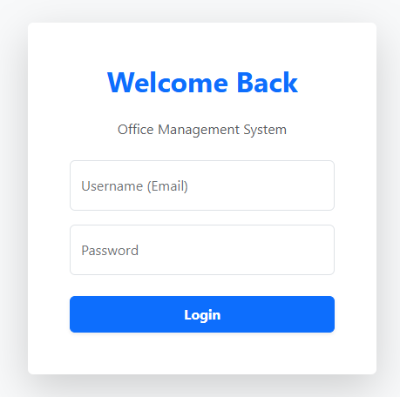
Admin Dashboard:
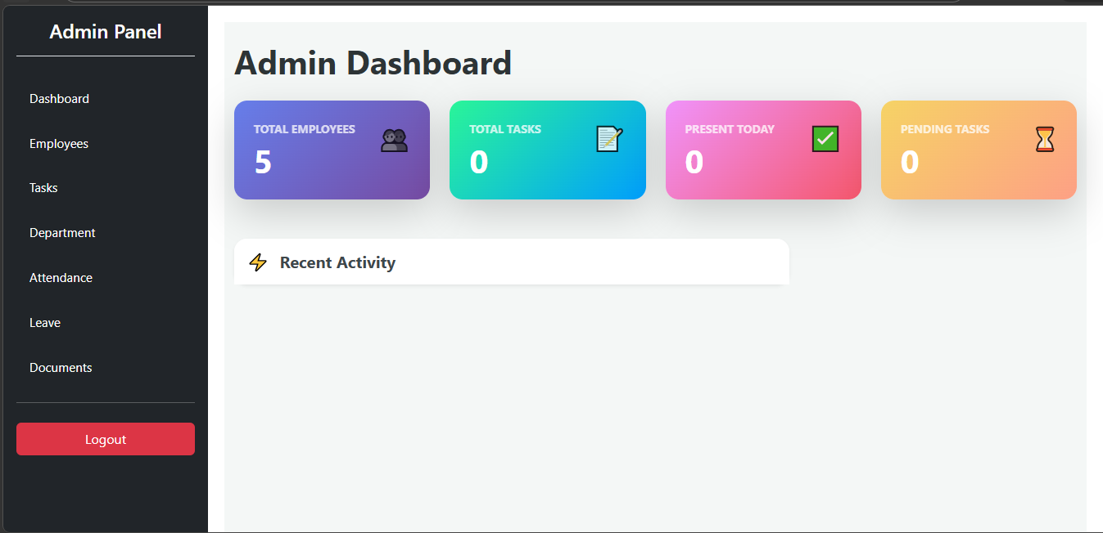
Employee Dashboard:
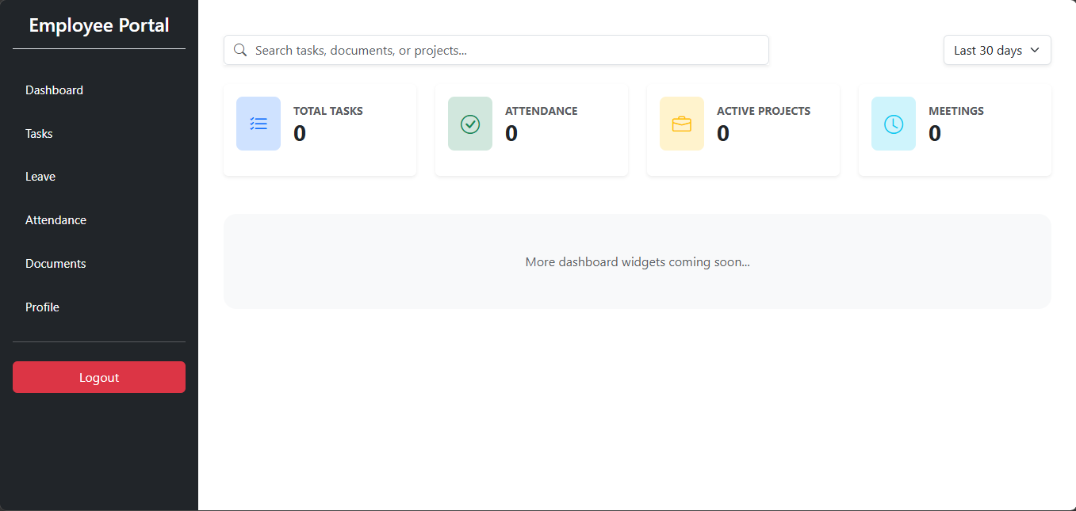

Documents Page:
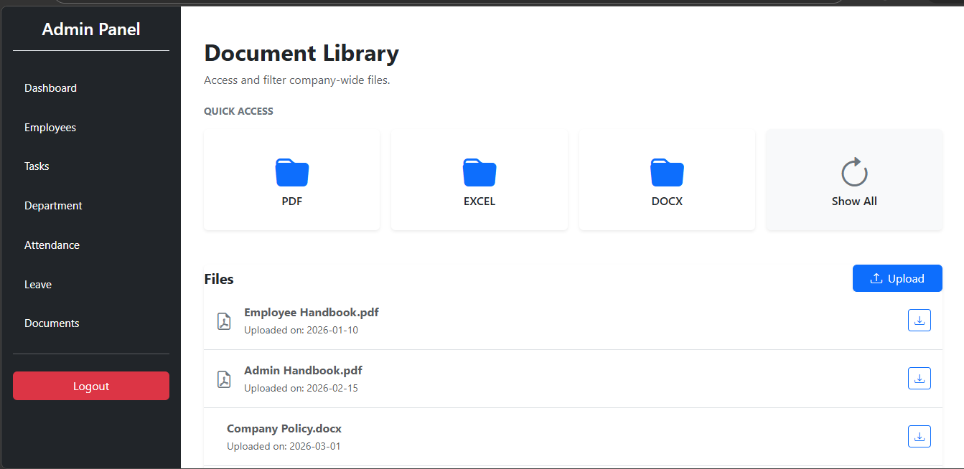

Tools / Software Setup

To make this system we installed and used the following:
- React
- Node.js
- MongoDB Compass
- GitHub
- VS Code / Antigravity

